Andorra
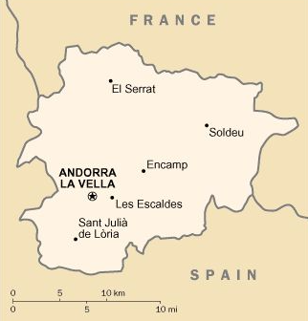
Chronology
c.803 Part of the Kingdom of the Franks.
23 Jan 843 Conceded to Sicfridus (Sunifrid) Count of Urgell
as a feudal domain by the Frankish king.
988 Count Borrell II of Urgell transfers some Andorran
holdings to the Bishop of Urgell, in exchange
for lands in Catalonia.
18 Apr 1095 Administration over the bishops holdings is given
to the vicomte Caboet as a fief (confirmed 29
Jun 1162); which on 14 Jan 1170 is transferred
to the Castellbò family, and then from 1208 to
Roger Bernat II comte de Foix.
27 Jan 1133 Remaining holdings of the Count of Urgell are given
to the Bishop of Urgell, later this is disputed
by the heirs of the count.
8 Sep 1278 Les Valls d'Andorra (Valleys of Andorra) is
constituted as a condominium in accordance with
a pareatge (charter) by the Count of Foix (from
12 Feb 1479, title is held by kings of Navarra)
and the Bishop of Urgell (in Aragón, later Spain)
(ratified 7 Oct 1282, amended 6 Dec 1288), the
co-princes are represented by vicars (veguer de
las valls); and each is entitled to tribute in
alternate years.
15 Oct 1303 Under Aragonese protection (by letters patent).
1396 - 1396 Occupied by Aragón.
11 Feb 1419 First parliament (Consell de la Terra) established.
1512 - 1513 Occupied by Aragón.
2 Aug 1589 The King of Navarra and Count of Foix becomes the
King of France.
20 Oct 1620 The County of Foix and Kingdom of Navarra become
part of the French crown lands; the title of
Andorran Co-prince is held thereafter by the
head of state of France.
22 Aug 1793 - 27 Mar 1806 French Republic renounces position of Co-prince.
27 Mar 1806 French protection revived, France represented by
prefect of Ariége.
26 Jan 1812 - 1814 Annexed by France (part of département of Sègre
[from 7 Mar 1813 Sègre-Ter département] see
under Catalonia). Following the incorporation of
Andorra into Catalonia (26 Jan 1812) as a
territory occupied by the army of France, the
status of the French co-ruler remained
unconfirmed.
30 May 1814 Former Andorran status confirmed by Treaty of Paris.
1834 - 1839 Andorra declares neutrality during Spanish Carlist
War (and again 1873-1876).
31 May 1866 Consell General de las Valls replaces the former
parliament.
3 Jun 1882 France represented by prefect of Pyrénées-Orientals
18 Aug 1933 - 9 Oct 1933 Unrest leads to intervention by French gendarmes.
7 Jul 1934 - 21 Jul 1934 Consell General elects adventurer Boris Skossyreff
(Skosyrev)(b. 1896 - d. 1989) sovereign prince
of Andorra (and self-declared regent for the
'absent' King of France), he is removed by Spanish
police acting for the Bishop of Urgell.
Jul 1936 - Nov 1940 French gendarmes garrison Andorra during the
Spanish civil war.
16 Jun 1940 - 14 Sep 1944 French Veguer loyal to "Vichy" France (from
14 Sep 1944, Free France); on 24 Sep 1940, Pétain
assumes the style of Co-prince.
15 Nov 1944 - 1945 Intervention by French gendarmes.
4 May 1993 Principality of Andorra (Principat d'Andorra).

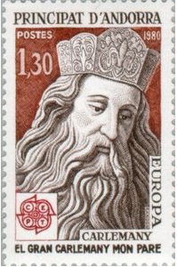 | 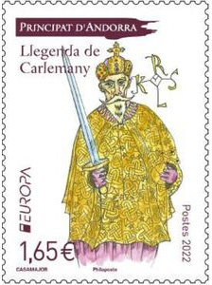
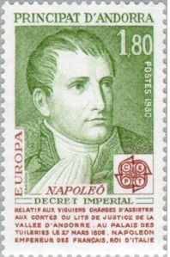
Co-princes (French heads of state)
1589 - 1793 see France
27 Mar 1806 - see France
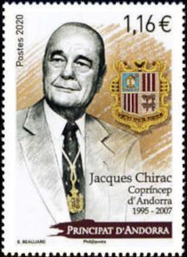 | 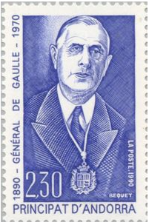
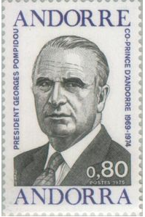 | 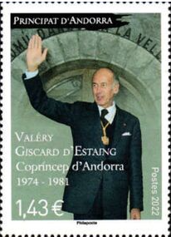
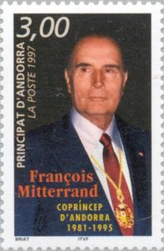
Co-princes (bishops of Urgel)
8 Sep 1278 - 12 Jan 1293 Pere d'Urtx i de Mataplana (d. 1293)
(Pedro de Urgio)
4 Jul 1695 - 17 Jan 1714 Julià Cano i Thebar (b. 1646 - d. 1719)
17 Sep 1714 - 27 Aug 1737 Simeó de Guinda y Apéztegui (b. 1669 - d. 1737)
5 May 1738 - 12 May 1747 Jordi Curado y Torreblanca (b. 1682 - d. 1749)
15 May 1747 - 2 Oct 1756 Sebastià Josep de Victoria de Emparán y de Loyola
(b. 1683 - d. 1756)
6 May 1757 - 8 Sep 1762 Francesc Josep Catalán de Ocón (b. 1701 - d. 1762)
10 May 1763 - 22 Apr 1771 Francesc Fernández de Xátiva y Contreras
(b. 1704 - d. 1771)
7 Jan 1772 - 15 May 1779 Joaquín de Santiyán y Valdivielso (b. 1733 - d. 1783)
27 Nov 1780 - 23 May 1783 Joan de García y Montenegro (b. 1716 - d. 1783)
31 Mar 1785 - 8 Dec 1795 Josep de Boltas i Vélez (b. 1738 - d. 1795)
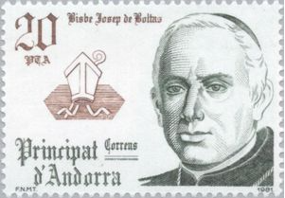
29 Oct 1797 - 23 Sep 1816 Francesc Antoni de la Dueña y Cisneros
(b. 1753 - d. 1821)
28 Jul 1817 - 27 Sep 1824 Bernat Francés y Caballero (b. 1774 - d. 1843)
20 Dec 1824 - 22 May 1827 Isidor Bonifaci López y Pulido (b. 1774 - d. 1827)
4 Nov 1828 - 22 Aug 1851 Simó Rojas de Guardiola i Hortoneda
(b. 1773 - d. 1851)
10 Mar 1853 - 26 Aug 1879 Josep Caixal i Estradé (b. 1803 - d. 1879)
26 Aug 1879 - 24 Sep 1901 Salvador Casañas i Pagès (b. 1834 - d. 1908)
(acting to 22 Sep 1879 and from 27 Jul 1901)
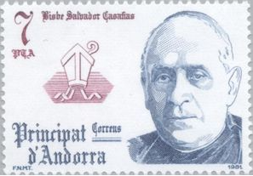
24 Sep 1901 - 27 Dec 1901 Ramon Riu i Cabanes (b. 1853 - d. 1901)
2 Jan 1902 - 10 Sep 1902 Toribio Martín (acting) (b. 1874 - d. 19...)
10 Sep 1902 - 6 Dec 1906 Joan Josep Laguarda i Fenollera (b. 1866 - d. 1913)
INCLUDEPICTURE "http://www.marki-pochtoy.ru/uploads/images/med/86dd80c8dbdf1265591914b7ffdd520b.jpg" \* MERGEFORMATINET INCLUDEPICTURE "http://www.marki-pochtoy.ru/uploads/images/med/86dd80c8dbdf1265591914b7ffdd520b.jpg" \* MERGEFORMATINET INCLUDEPICTURE "http://www.marki-pochtoy.ru/uploads/images/med/86dd80c8dbdf1265591914b7ffdd520b.jpg" \* MERGEFORMATINET INCLUDEPICTURE "http://www.marki-pochtoy.ru/uploads/images/med/86dd80c8dbdf1265591914b7ffdd520b.jpg" \* MERGEFORMATINET INCLUDEPICTURE "http://www.marki-pochtoy.ru/uploads/images/med/86dd80c8dbdf1265591914b7ffdd520b.jpg" \* MERGEFORMATINET 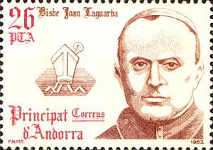
30 Apr 1907 - 11 Jul 1907 Josep Pujargimon Camardons (acting)
11 Jul 1907 - 7 Jan 1919 Joan Baptista Benlloch i Vivó (b. 1864 - d. 1926)
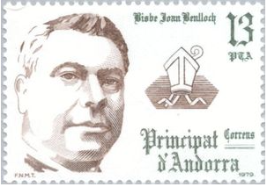
2 Jul 1919 - 1 Jun 1920 Jaume Viladrich i Gaspa (acting) (b. 1865 - d. 1926)
1 Jun 1920 - 31 Jan 1940 Justí Guitart i Vilardebò (b. 1875 - d. 1940)
INCLUDEPICTURE "http://www.marki-pochtoy.ru/uploads/images/med/de6697f8e6ce90036ccbf003ab3ba905.jpg" \* MERGEFORMATINET INCLUDEPICTURE "http://www.marki-pochtoy.ru/uploads/images/med/de6697f8e6ce90036ccbf003ab3ba905.jpg" \* MERGEFORMATINET INCLUDEPICTURE "http://www.marki-pochtoy.ru/uploads/images/med/de6697f8e6ce90036ccbf003ab3ba905.jpg" \* MERGEFORMATINET INCLUDEPICTURE "http://www.marki-pochtoy.ru/uploads/images/med/de6697f8e6ce90036ccbf003ab3ba905.jpg" \* MERGEFORMATINET INCLUDEPICTURE "http://www.marki-pochtoy.ru/uploads/images/med/de6697f8e6ce90036ccbf003ab3ba905.jpg" \* MERGEFORMATINET 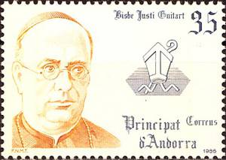
2 Feb 1940 - 15 Apr 1943 Ricard Fornesa i Puigdemasa (acting)
15 Apr 1943 - 19 Jun 1969 Ramon Iglésias Navarri (b. 1889 - d. 1972)
INCLUDEPICTURE "http://www.marki-pochtoy.ru/uploads/images/med/d96426b88855ca2c2056b9aa41330194.jpg" \* MERGEFORMATINET INCLUDEPICTURE "http://www.marki-pochtoy.ru/uploads/images/med/d96426b88855ca2c2056b9aa41330194.jpg" \* MERGEFORMATINET INCLUDEPICTURE "http://www.marki-pochtoy.ru/uploads/images/med/d96426b88855ca2c2056b9aa41330194.jpg" \* MERGEFORMATINET INCLUDEPICTURE "http://www.marki-pochtoy.ru/uploads/images/med/d96426b88855ca2c2056b9aa41330194.jpg" \* MERGEFORMATINET INCLUDEPICTURE "http://www.marki-pochtoy.ru/uploads/images/med/d96426b88855ca2c2056b9aa41330194.jpg" \* MERGEFORMATINET 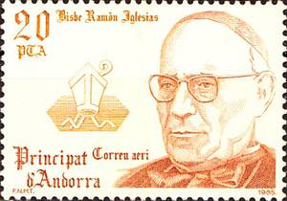
19 Jun 1969 - 31 Jan 1971 Ramon Malla Call (acting) (b. 1922 - d. 2014)
31 Jan 1971 - 12 May 2003 Joan Martí Alanís (b. 1928 - d. 2009)
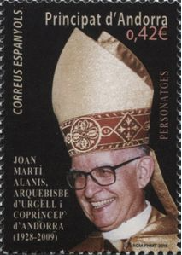
12 May 2003 - Joan Enric Vives Sicília (b. 1949)
Personal representatives of the French co-prince
Sep 1993 - Feb 1997 Jean-Yves Caullet (b. 1957)
Feb 1997 - May 1999 Pierre de Bousquet de Florian (b. 1954)
May 1999 - Jul 2002 Frédéric de Saint-Sernin (b. 1958)
Jul 2002 - Jun 2007 Philippe Massoni (b. 1936 - d. 2015)
Jun 2007 - Sep 2008 Emmanuelle Mignon (f) (b. 1968)
Sep 2008 - May 2012 Christian Frémont (b. 1942 - d. 2014)
May 2012 - Jan 2015 Sylvie Hubac (f) (b. 1956)
Jan 2015 - Jun 2016 Thierry Lataste (b. 1954)
Jun 2016 - May 2017 Jean-Pierre Hugues (b. 1951)
May 2017 - Patrick Strzoda (b. 1952)
Personal representatives of the episcopal co-prince
1993 - 20 Jul 2012 Nemesi Marquès Oste (b. 1935)
20 Jul 2012 - Josep Maria Mauri Prior (b. 1941)
First syndics (from 4 May 1993, general syndics)
1841 - 1847 Josep Picart
1847 - 1858 Bonaventura Riba (acting)
1858 - 1861 Gil Areny
1861 - 1865 Francesc Duran (1st time)
1865 - 1866 Joaquim de Riba
1866 - 1868 Guillem Areny de Plandolit (b. 1822 - d. 1876)
1868 - 1875 Nicolau Duedra
1875 - 1878 Guillem Mora
1878 - 1880 Bonaventura Moles
1880 - 1881 Joan Pla Calvo
1881 Josep Palmitjavila (1st time)
1881 - 1883 Francesc Duran (2nd time)
1884 - 1885 Josep Palmitjavila (2nd time)
1886 Francesc Duran (3rd time)
1886 - 1888 Francesc Maestre
1888 - 1897 Antoni Moles
(jointly with following)
1893 - 1898 Bonaventura Maestre (1st time)
1899 - 1901 Josep Calva
1902 - 1905 Bonaventura Maestre (2nd time)
1906 - 1911 Pere Moles
1911 - 1912 Bonaventura Maestre (3rd time)
1912 - 1915 Bonaventura Moles
1915 - 1917 Pere Font (1st time)
1918 - 1920 Josep Vilanova
1920 Josep Grepa (acting)
1920 - 1923 Bonaventura Villarubia
1924 - 1927 Pere Font (2nd time)
1928 - 19 Aug 1933 Roc Pallares
Sep 1933 - 1936 Pere Torres
1936 - 1937 Francesc Molné
1937 - 1 Jan 1961 Francesc Cairat Freixes (b. 1880? - d. 19...)
1 Jan 1961 - 31 Dec 1966 Julià Reig-Ribó (1st time) (b. 1911 - d. 1996)
31 Dec 1966 - 29 Dec 1972 Francesc Escudé Ferrero (b. ... - d. 1996)
29 Dec 1972 - 30 Dec 1978 Julià Reig-Ribó (2nd time) (s.a.)
30 Dec 1978 - 4 Jan 1982 Estanislau Sangrà Font (b. 1946)
4 Jan 1982 - 12 Jan 1990 Francesc Cerqueda Pascuet (b. 1942)
12 Jan 1990 - 15 Feb 1991 Josep Maria Beal Benedico
15 Feb 1991 - 12 Apr 1992 Albert Gelabert Grau (b. 1948)
12 Apr 1992 - 19 Jan 1994 Jordi Farràs Forné
19 Jan 1994 - 10 Mar 1997 Josep Dallerès Codina (1st time) (b. 1949)
10 Mar 1997 - 17 May 2005 Francesc Areny Casal (b. 1959)
17 May 2005 - 19 May 2009 Joan Gabriel Estany (b. 1963)
19 May 2009 - 28 Apr 2011 Josep Dallerès Codina (2nd time) (s.a.)
28 Apr 2011 - 2 May 2019 Vicenç Mateu Zamora (b. 1961)
2 May 2019 - Roser Suñé Pascuet (f) (b. 1960)
Heads of government
8 Jan 1982 - 21 May 1984 Òscar Ribas Reig (1st time) (b. 1936)
21 May 1984 - 12 Jan 1990 Josep Pintat-Solans (b. 1925 - d. 2007)
12 Jan 1990 - 7 Dec 1994 Òscar Ribas Reig (2nd time) (s.a.)
7 Dec 1994 - 27 May 2005 Marc Forné Molné (b. 1946)
27 May 2005 - 5 Jun 2009 Albert Pintat Santolària (b. 1943)
5 Jun 2009 - 28 Apr 2011 Jaume Bartumeu Cassany (b. 1954)
28 Apr 2011 - 12 May 2011 Pere López Agràs (acting) (b. 1971)
12 May 2011 - 23 Mar 2015 Antoni Martí Petit (1st time) (b. 1963)
23 Mar 2015 - 1 Apr 2015 Gilbert Saboya Sunyé (acting) (b. 1966)
1 Apr 2015 - Antoni Martí Petit (2nd time) (s.a.)

INCLUDEPICTURE "http://www.marki-pochtoy.ru/uploads/images/med/45d716f09378cf86e310736658b4e769.jpg" \* MERGEFORMATINET INCLUDEPICTURE "http://www.marki-pochtoy.ru/uploads/images/med/45d716f09378cf86e310736658b4e769.jpg" \* MERGEFORMATINET INCLUDEPICTURE "http://www.marki-pochtoy.ru/uploads/images/med/45d716f09378cf86e310736658b4e769.jpg" \* MERGEFORMATINET INCLUDEPICTURE "http://www.marki-pochtoy.ru/uploads/images/med/45d716f09378cf86e310736658b4e769.jpg" \* MERGEFORMATINET INCLUDEPICTURE "http://www.marki-pochtoy.ru/uploads/images/med/45d716f09378cf86e310736658b4e769.jpg" \* MERGEFORMATINET 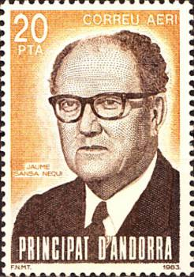
Spanish Andorra - Jaime Sansa Nequi
INCLUDEPICTURE "http://www.marki-pochtoy.ru/uploads/images/med/3e13a2e2460c1047a146127a8a905c6a.jpg" \* MERGEFORMATINET INCLUDEPICTURE "http://www.marki-pochtoy.ru/uploads/images/med/3e13a2e2460c1047a146127a8a905c6a.jpg" \* MERGEFORMATINET INCLUDEPICTURE "http://www.marki-pochtoy.ru/uploads/images/med/3e13a2e2460c1047a146127a8a905c6a.jpg" \* MERGEFORMATINET INCLUDEPICTURE "http://www.marki-pochtoy.ru/uploads/images/med/3e13a2e2460c1047a146127a8a905c6a.jpg" \* MERGEFORMATINET INCLUDEPICTURE "http://www.marki-pochtoy.ru/uploads/images/med/3e13a2e2460c1047a146127a8a905c6a.jpg" \* MERGEFORMATINET 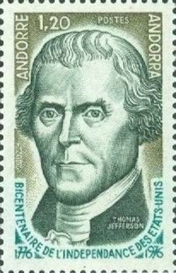

Compiler FLN

